NATIONAL UNIVERSITY OF MODERN LANGUAGE ISLAMABAD
Lab # 01


Submitted to:
Ms. Saadia Shabbir
Submitted by:
Zulqarnain Hassan (SP21379)
Ehsan Mehmood (SP21371)
Subject: …………………… Web engineering
Department: ……………… BSSE-5-Afternoon
Date: ……………………… 18-09-2024

Task 01
What happens when you remove or modify the path in the URL?
I visit “https://www.geeksforgeeks.org/” and when I remove “data-science-for-beginners” The browser typically load the homepage of the website


How does the browser respond when you enter an incorrect path?
A 404 error occurs when the requested path on the server does not exist. The server responds with a 404 status code and may display a custom "404 Page Not Found" error message.

What do you notice about URLs that use http versus https?
HTTP (HyperText Transfer Protocol):
Data is transmitted in plain text, meaning it is not encrypted.
HTTPS (HyperText Transfer Protocol Secure):
Data is transmitted using encryption, making the communication between your browser and the server more secure.

Task 02

I. Are there any noticeable differences in how the website is displayed across different browsers?

Generally, modern websites use standardized web technologies (HTML, CSS, JavaScript), and popular browsers adhere to web standards. As a result, differences in layout and appearance across browsers are usually minimal. However, subtle differences may appear in: Fonts, Spacing and Margins, Animations etc.

“https://www.geeksforgeeks.org/data-structures/” in Edge.



“https://www.geeksforgeeks.org/data-structures/ “ in chroom.



II. What differences do you observe in loading times? What might cause these differences?

Chrome and Edge (both based on Chromium) often have similar load times due to using the same underlying rendering engine (Blink). Firefox may show slightly different loading times, but the differences are typically minor unless the site uses features that are optimized for Chromium browsers.

III. How do browser developer tools help you understand the structure and rendering of a webpage?
Developer tools allow me to inspect the HTML structure of the page, showing the DOM tree (Document Object Model), which represents the structure of the webpage as it is rendered by the browser.
We can see the hierarchy of elements and the associated CSS styles applied to each element. This helps understand how the browser interprets and renders the webpage layout.
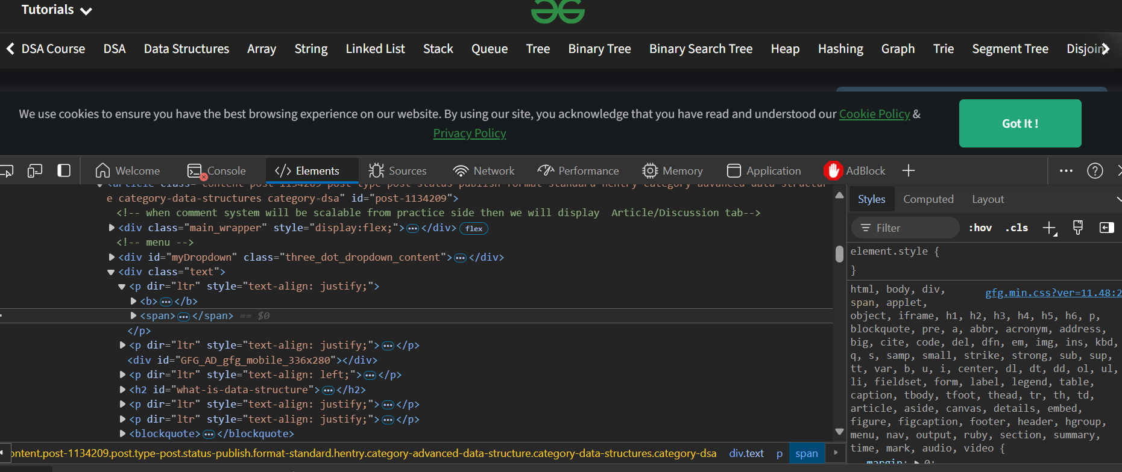

Task 03
1. How do different file formats contribute to the overall content of a website?
Various file formats contribute to different aspects of a website's content:
Images (.jpg, .png, .gif, .svg, etc.):
These formats are used to display visual content like photos, icons, logos, and other graphical elements.
Documents (.pdf, .docx, etc.):
PDFs are often used for downloadable content like reports, forms etc.
Videos (mp4, webm, etc.):
Videos are typically embedded on websites using formats like MP4 or WebM to provide multimedia experiences.
Audio (mp3, wav, etc.):
Audio files, like MP3 and WAV, are used for background music, podcasts, or audio-based learning material.
HTML (.html):
HTML files are the core structure of a webpage, defining the layout and content.
CSS (.css):
CSS files are responsible for the visual design, including colors, fonts, layouts, and responsiveness.
JavaScript (.js):
JavaScript files add interactivity, animations, and dynamic functionality, such as form validation, interactive maps, and AJAX requests.
Each file format adds a unique layer to a website, enhancing its interactivity, aesthetics, functionality, and content delivery.
2. What is the significance of file size in terms of web performance?
File size directly impacts web performance in the following ways:
Larger files take longer to download, resulting in slower page load times. For example, large images or videos can significantly delay rendering if they aren't optimized.
Larger file sizes consume more bandwidth, which can be a concern for both the server hosting the content and the users, especially those on slower internet connections or limited data plans.
Users are more likely to leave a slow-loading website. Optimizing file sizes improves user retention by making the site faster and more responsive.
For mobile users, especially those with limited bandwidth or slower network speeds, smaller file sizes are crucial for delivering a smooth experience.

3. What files are saved when you download a webpage, and what role does each file play in rendering the page?
When you download a webpage using the browser’s “Save As” feature, several types of files are saved.
HTML: Provides the structure of the content, such as text and links.
CSS: Defines the layout and visual appearance of the content.
JavaScript: Adds interactivity and dynamic behavior to the content.
Images/Fonts: Enhance the visual appeal of the content.
Together, these files allow a browser to fully render the page, even offline, ensuring that the appearance and behavior remain consistent with the original website.

Task 04

